Educational Philosophy and Theory 2015

Vol. X, No. X, 1–3, http://dx.doi.org/10.102901910191019

Pedagogy that Provokes Strategy and Imagination in Finance

JOY WHITTON
PhD candidate, Faculty of Education, Monash University
Abstract
Paul Ricoeur’s theory of imagination is used as a lens with which to interpret manifestations of imaginative learning and thinking in an ethnographic account of a post-graduate finance unit. Finance is not generally regarded as an imaginative enterprise, an assumption my doctoral research seeks to investigate. However this subject was run as a high tech simulation in which students in groups took roles in an imaginary bank, trading currency in the first module and managing loans and deposits in the second module of the semester. This raised the question: What opportunities for imagination and creativity were afforded by technology, simulation pedagogy and role play? I argue that language (including mathematics) and other disciplinary skills, tools and methods amplify the cognitive power of imagination which I link to Ricoeur’s theory. The simulation pedagogy motivated students to form various financial strategies based on their tool-enhanced understanding of financial information. By drawing attention to creative teaching and its potential to foster imagination as well as critical thinking, this ethnographic case allowed me to critique Ricoeur’s theory of imagination.
KEYWORDS: imagination, Ricoeur, creativity, critical thinking, strategy, Clark, Dennett

Introduction
Creative and critical thinking is given at least rhetorical support in 75 per cent of graduate attributes named by universities in Australia (McWilliam, 2007). This institutional objective, opens up a space – as it were a licence – for higher education teachers to foster students’ imagination. By teaching in new and creative ways teachers open up possibilities for their students to have potentially rich learning experiences that use their imaginative capacity. In this article I look at how student learning may be enriched by simulation pedagogy which makes personally meaningful use of disciplinary tools and skills to imagine possible future scenarios and then to create strategy based on these imagined scenarios.

Finance Ethnography
The following ethnographic case study demonstrates an attempt to make the most of this space by one educator. Money, Market Dealing is a post-graduate Finance subject taught in Monash University’s Caulfield campus. The campus specialises in post-graduate business degrees in a faculty that attracts a high number of international students as well as local industry people upgrading their qualifications. The lecturer in charge introduced STARLab, a high tech, purpose-built Simulated Teaching and Research Laboratory, which simulates a bank’s treasury dealing room. STARLab is situated in a large room with circular tables for six or so students on which sit computers driven by market simulation software and the students play roles in banks that go by names like ‘Maybank’, ‘Bank Negara Indonesia’, ‘J P Morgan’, ‘Lloyds’, ‘Hong Kong Bank’, and ‘Rabobank’. The laboratory functions as a ‘capstone’ subject. Students bring theoretical knowledge previously learnt in their degree and apply it in final year to demonstrate that they can put their learning into practice before entering the workforce. A promotional video says that STARLab exposes students to situations and events that demand they draw on prior knowledge, and engineer financial strategies using a variety of financial ‘instruments’ to hedge risks and seek profits in competition with other students (other traders). A photo shows the set-up of the room, illustrating an environment conducive to active learning.

© 2013 Philosophy of Education Society of Australasia

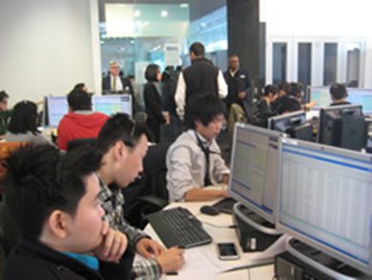

I am attracted by the idea of including the unit in my ethnographies of imaginative university teaching and learning for two reasons: firstly, finance is not generally regarded as an imaginative enterprise , which is an assumption my research seeks to investigate; and secondly, because the whole semester is run as a simulation. What opportunities for fostering imagination – the subject of my PhD research – are afforded by simulation technology, and – a separate, though linked, question – what opportunities are offered by simulation pedagogy, for imagination and creativity? Simulation has its origins in anaesthesia and aviation where the stakes are high and safety is paramount. It has been defined by Fanning and Gaba as ‘an imitation of some real thing, state of affairs, or process’. Role play, of broader and older lineage than simulation, broadens the definition to include rehearsal for activities or roles, learning behaviours, operating as a team and interacting socially (Fanning and Gaba, 459).

Ricoeur’s Theory of Productive Imagination
Ricoeur’s theory of imagination, which I have used to interpret practices in the subject, suggests that imagination is a form of thinking, and is therefore useful to try to understand how it may be integral to education and learning. He argues that theorists have focused too much on ‘reproductive’ forms of imagination at the expense of ‘productive’ forms, which offer greater insight into human creativity and agency. Ricoeur builds a general picture of ‘productive imagination’ with metaphors, models, and narrative as descriptive ‘tools’ that combine and connect things to produce shifts in perspective, from which ﬂow insights and innovative ways of thinking about reality (1979; 1991a; 1991b; 2003; Taylor 2006). I have discussed this elsewhere (2014; Peters and Besley, 2013) and will cover his briefly here.
In fresh metaphors, for example, he argues that the new meaning creates a resemblance that can be ‘seen’ and understood, rather than simply finding or expressing it. He says, in effect, that a metaphoric image gives a shape to meaning.
It is … at the moment when a new meaning emerges out of the ruins of the literal predication that imagination offers its specific mediation (my emphasis)…. Imagination is the apperception, the sudden glimpse, of a new predictive pertinence, It is, to use Wittgenstein’s expression in Philosophical Investigations ‘seeing as…’…. The work of the imagination is to schematise metaphorical attribution. Like the Kantian schema, it gives an image to an emerging meaning (1991a, 172–3).
Thus, for Ricoeur, fresh metaphors reveal a new way of seeing their referents. They invent new meaning–are not merely rhetorical ornaments–but have genuine cognitive import. Imagination is the ability to make a mental leap and align heterogeneous ideas or totally different domains of experience, and in doing so, to tell us something new about reality.
Ricoeur argues that just as metaphors affect a displacement of an overall meaning through an unlikely combination, narrative combines agents, circumstances, action, goals, causes, and chance into a meaningful, intelligible amalgamation that is more than a simple succession of events. Ricoeur argues that the power of imagination in metaphors and narrative can, like models in science, redescribe phenomena in terms of functions and in doing so model novel understandings of reality, new ways of being and acting in the world. They become heuristic instruments of interpretation and discovery by forming fresh connections which can hypothesize consequences of actions, including alterations to institutions and changes in values.
The power of these imaginative linguistic tools such as metaphors, models and narrative - ‘‘props’’ is emphasized when connected with Clark’s thesis of the ‘extended mind’ (1997).
Simple external props enable us to think better and hence create more complex props and practices, which in turn, turbo-charge our thoughts a little more, which leads to even better props. (p. 62)
Clark contends, drawing on robotics, that we control our physical surroundings in ways that alter how we interpret and act in and on them—that is, we are actively and resourcefully engaged with our world (rather than passively receiving it). Clark builds on Daniel Dennett’s argument that our cultural tools endow us with intelligence (Dennett, 1995, pp. 377-8).
These theorists argue that language (including mathematics) and other disciplinary skills, tools and methods amplify the cognitive power of imagination.
Taking these ideas on board in the following sections from an ethnography of the finance class, I draw attention to creative teaching and the opportunities for fostering imagination in a non arts-based professional subject when that capacity is not usually considered part of the curriculum. It also allows me to critique Ricoeur’s theory of imagination in an epistemological context.
I will of necessity discuss only two brief sections from the full ethnography. (All participants’ comments and work is reproduced with permission.)

Finance Ethnography
As Jeff speaks to the class, he constantly switches back and forth from the simulation game to what it is for: the learning objectives of the game, meaning the game is simultaneously simulation and pedagogical in focus. For example, there is a debriefing each week to clarify the lessons to be had from the day’s trading: the trading is not an end in itself. In terms of my research on fostering imagination, this implies his simulation pedagogy offers students two positions that they can mentally assume: banker and learner. It strikes me that assuming different imaginary positions in thinking offers practice in flexibility, in not being aligned to just one way of thinking. In this way, I conclude, simulation pedagogy offers rich opportunities to cultivate the imagination of students. This could also be observed at another stage in the course when his commentary tutored students in both how to think about the game and to develop their banking skills further. He urged them:
The CEOs are not reactive, they act according to a script. But they form the market. They continue with their script. They need to develop a series of strategies; just one will not work.
A second example illustrates the same point:
We are not trying to make you a trader. We’re giving you an experience of being a trader – the experience of thinking about the issues, to develop the characteristics of what a good trader will have.
A key benefit to this imaginary taking up of positions (banker and learner) is the flexibility to shift perspectives. The displacement of perspectives involves imagination and it gives rise to multiple positions from which to exercise criticality. Hence the link made in the creativity literature on the interwoven aspects of imagination and critical thinking (Nickerson, 1999; Bosanquet, Winchester-Seeto and Rowe, 2012; Dawkins, 1989). In terms of finance, an aspect of criticality is developing the ability to act ethically, which in a post GFC is regarded as a duty of care in finance education. He advises,
You can’t work in financial markets for long without ethical trading practices.
He says it keeps him awake at night – that they may become rogue traders. He points out that trading ethically is integral to learning to mitigate risk –which is central to the skill development objectives of the course. He reminds them
The good name of your institution is important for markets.
I interpret this as an invitation to consider the repercussions financial decisions have beyond the walls of the bank and its financial imperatives. The invitation directs them to reflect and to imagine a different world, or a change in perspective for themselves at least, through education. Important, and potentially divergent, as this invitation is, however, it did not change the direction of the game that I could observe and one would need to see what actions the assessed assignments, if not the game itself, contained for students to display evidence of the progress of their thoughts towards imagining a different world. I found no evidence for this in the assignments.

Forming Strategies: Reproductive and Productive Forms of Imagination
The loans and deposits module is the second module and runs for five weeks of the semester. It is the main focus of the subject according to Jeff and is a step up in complexity from the currency trading module (Interview, December 2013). In an interview, Jeff explains the relationship of the first module on foreign exchange to the second one on loans and deposits:
… when we move to the next module, [loans and deposits] their capital is strategy now …-– because you’re trying to position your bank for what will happen in the future (my emphasis).(Post-class interview)
The key point here in terms of fostering imagination is the emphasis on strategy: ‘because you’re trying to position your bank for what will happen in the future’. Forming a strategy goes beyond immediate experience and is about future thinking, however it is not about predicting the future but devising a course of action in order to attain a desired goal. Doing this involves imagining the outcomes of various plans of action.
The key source of data about what the students learned from their trading experience in the loans and deposits module was the final assignment, which was to be written by students as if it was a report to the CEO on the bank (the lecturer) but with added sections for reflection on their learning.
As with the currency trading module, the students act as a bank in groups of three. Essentially, they trade with other banks, lending money and taking deposits from other banks as well as tendering with corporations (via the Central Bank) who wish to borrow (loan, from the bank’s point of view) or invest (borrow, from the bank’s point of view) at competitive rates for certain periods of time. The interest rates each bank adopts and the rarity of occasions when contracted ‘maturity’ dates of the loans (which are the bank’s ‘assets’) coincide with the maturity dates of deposits (the bank’s ‘liabilities’), means this trading activity carries with it risk. In a teaching situation, this presents a learning moment: thinking about what risks are involved and the ways to mitigate them. For example, if they don’t have enough cash they can’t meet their obligations to depositors wanting to withdraw money, which would constitute bankruptcy. Risk-taking is a consistent theme in the literature on creativity of which imagination is an element (Lucas, 2013), so it is not surprising to see it appearing in creative teaching.
One student in the team, the ‘position keeper’ (or accountant) records trading events on their balance sheet using an excel spreadsheet, which is one of the financial tools I see groups refer to periodically each week during trading; this person uses it to produces charts and graphs which track their activities (such as, what proportion of my loans are to the corporate sector? What, therefore, is my exposure to risk?). One example is 'yield curves’ which graph the various maturity dates of deposits and loans. Interpreting what these graphs depict about the practical field involves imagination – ‘reading off’ or reinterpreting the data contained in the graph and applying it back to the actual situations it is derived from – which is, how to ensure that the margin between the deposit interest rates and the loan interest rates, and the gaps between their maturity dates, will amount to a profit. This is because it requires imagination to move between such abstract depictions and understanding the financial data they are derived from and depict. These graphs are mathematical tools which help them make profit projections, based on different maturity dates of deposits and loans and therefore total (‘net’) interest rate income, and their forecasts of interest rate directions. The value of numbers and maths is ‘they summarise things,’ Jeff exhorts. It is how they can track the bank’s performance, and understand reasons for likely changes of fortune in it. The graphic tools (which are examples of ‘reproductive imagination’ in Ricoeur’s terms) improve the accuracy of the powers of prediction, amplifying the strategic capability of the student users. They illustrate Daniel Dennett’s and Andy Clark’s idea of intellectual ‘tools’ which bootstrap the tool user’s cognitive ability. If they imagine what the information means, it can subsequently feed the creation of appropriate strategies, which are examples of ‘productive imagination' in Ricoeur’s terms.
Some reports show limited analysis of economic indicators. By limited analysis I mean they will note the correlation between an event – such as poor retail sales and an interest rate cut; the Consumer Price Index being lower than expected and an interest rate cut; or news of Greece’s withdrawal from the European Union causing global economic chaos with long-term lowering of interest rates – but their graphs are not linked closely to an interpretation of what those relationships mean for their strategies. Lloyd’s report, for example notes these things (Lloyd Student assignment, p.3-4) but its graphs and discussion of weekly trading sessions remains at the level of description (p. 4-6). Its yield curve analysis section, too, describes correlations:
At the beginning, the yield curve was a humped curve. This was due to the 50pb cut at the previous trading session.
During the break and end, the figure did not differ much from the 75 bp and 50bp cut rate.
In contrast, in this section of a report by another bank, HSBC, these graphs are the tool used to represent a relationship between current events and their degree of correlation with movements in interest rates.
Summary of Key Events and Impacts on Interest Rates
Events | Impact (Observed Over All Trading Sessions)
CBA Cash Rate Intervention | Decrease (Certain & Immediate)
Rapid Depreciation in AUD Exchange Rate | Decrease (High Possibility)
Increase in Unemployment Figure | Decrease (Medium Possibility)
Balance of Payment Higher Than Expected | Decrease (Lower Possibility)

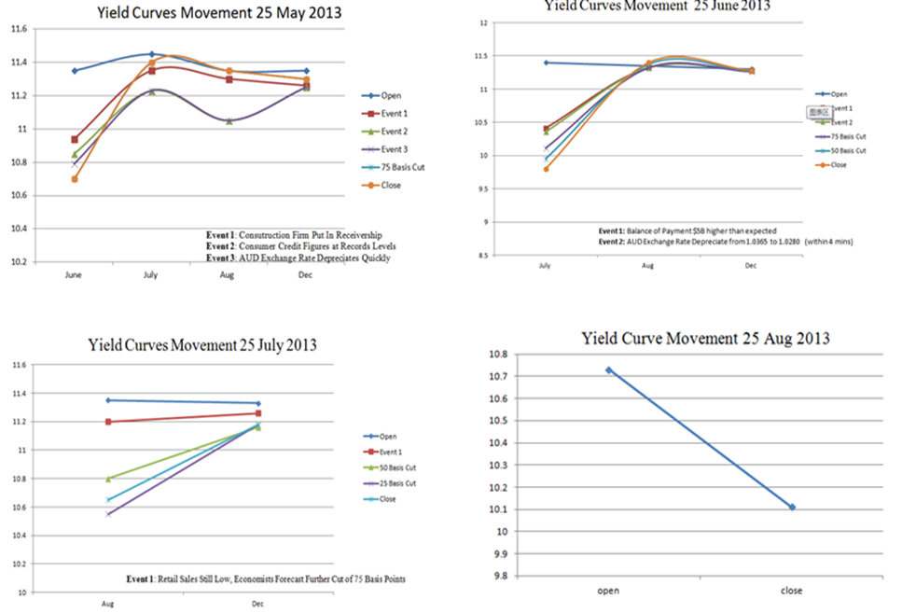
Figure 1: HSBC Loans and Deposits Report, p. 6 Reproduced by permission
This section of the HSBC report not only summarised how the table and yield curve describes the impact of news and events on interest rates, it went further:
We noticed that the yield for the next shortest maturity is generally the highest among all maturities and such observation provides useful insights in our strategy making. Also the shape of the yield curves does not necessarily remain unchanged over time or shifts to one direction only. Even though we hold a view of decreasing interest rate, decisions with regards to the next shortest maturity should be made cautiously. Overall, the actual market aligned with our forecast closely thus strategies we developed and implemented should add profits to our bank. (HSBC Loans and Deposits Report, p. 6)
This discussion shows that the representation of yield curves was able to be interpreted by the team in terms of forward thinking, or strategy (‘decisions with regards to the next shortest maturity should be made cautiously’). Making strategy implies creating ideas for action that take us beyond immediate experience but that are suggested to use by our interpretation of current scenarios. This is comparable to how John Dewey conceived of the imagination, as involved in making inferences from what is given to what is possible: from what is present to what is absent. It is therefore an act of thinking and of reasoning.
Suggestion is the very heart of inference; it involves going from what is present to something absent. Hence, it is more or less speculative, adventurous. (1910, p. 75)
Reasoning is also an imaginative process because it includes imagining the consequences of suggestions if they were applied: these consequences go beyond experience. This is why Dewey states that ‘inference is always an invasion of the unknown, a leap from the known’ (2004, p. 152). Dewey argued that imagination enables us to create ideas that go beyond what is given in concrete experience but which are also ‘effective’ because imagining likely consequences that ignore the facts of the situation are unlikely to be effective in operating on and interacting with, that situation (Bleazby, 2011). Dawkins argued similarly, but in scientific language, called the process ‘setting up a model in your head’ (1989, p. 59). The finance simulation class was based on a design for learning that provided for several weeks of trying out strategies. That the strategies were played out does not negate the strategic thinking done in preparatory work for each week’s trading and in the fast-paced decisions that were made on the day. In Ricoeur’s terms, the strategizing is evidence of ‘productive imagination’ because strategy involves flexibly considering alternative plans each designed to produce an outcome. The strategy in its turn is based on understanding the combination of contextual and leverage factors and blending imaginative and critical thinking.
For reasons of brevity, this article does not discuss the series of actions teams devised to manage various forms of banking risk – interest rate risk, liquidity risk. Suffice it to say that what they showed was a systematic series of actions, which composed the strategy that was designed to bring about a desired outcome.

Conclusion
As demonstrated by the finance case study, financial strategy formation provides a new context to illustrate the operation of imagination as semantic innovation. Ricoeur’s discussion of models in science as redescriptions bring us closer to its use in graphs and charts in finance in the sense that models provide a link to metaphor’s power to redescribe phenomena (1991b). This is because they are models for understanding, not models of real things, by which he means they are heuristic fictions for redescribing aspects of reality. This case study suggests that financial theory and tools provide their users with models which redescribe the practical field of the financial situation, providing the grounds to forecast effects and propose strategic action to bring about intended outcomes – profits usually. Graphs isolate certain factors, abbreviate them, and by setting off how they relate to each other they redescribe those phenomena in new formulations of the problem – this is the work of reproductive imagination. Productive imagination underpins their ability to make a mental leap and construct strategies likely to be effective. Both these phases involve imagination. By providing an authentic environment, the simulation unleashes the motivation to want to use the tools fluently and make the mental leap of converting the restructured knowledge into a strategy likely to lead to banking success.
References
Bleazby, J. (2011). Overcoming relativism and absolutism: Dewey's ideals of truth and meaning in philosophy for children. Educational Philosophy and Theory, 43(5), 453-466. doi: 10.1111/j.1469-5812.2009.00567.x
Bosanquet, A., Winchester-Seeto, T., & Rowe, A. (2012). Social inclusion, graduate attributes and higher education curriculum. Journal of Academic Language and Learning, 6(2), 73-87.
Clark, A. (1997). Being There: Putting Brain, Body and World Together. Cambridge, Massachusetts: The Massachusetts Institute of Technology Press.
Dennett, D., C. (1995). Darwin's Dangerous Idea: Evolution and the Meanings of Life. New York: Simon and Schuster.
Dewey, J. ((1910)1997). How We Think: A Restatement of the Relation of Reflective Thinking to the Educative Process. Dover Publications: Mideola, NY.
Dewey, J. (2004). Democracy and Education. Mineola, NY: Dover Publications.
Fanning, R., & Gaba, D. (2008). Simulation-based Learning as an Educational Tool. In J. Stonemetz & K. Ruskin (Eds.), Anesthesia Informatics (pp. 459-479).
Lucas, B., G. Claxton and E. Spencer (2013), Progression in Student Creativity in School: First Steps Towards New Forms of Formative Assessments, OECD Education
Working Papers, No. 86, OECD Publishing. http://dx.doi.org/10.1787/5k4dp59msdwk-en

McWilliam, E., & Dawson, S. (2007a). Understanding Creativity: A survey of 'creative' academic teachers: A report for the Carrick Institute for Learning and Teaching in Higher Education. Retrieved from http://www.altcexchange.edu.au/system/files/handle/fellowships_associatefellow_report_ericamcwilliam_may07.pdf.
Nickerson, R. (1999). Enhancing creativity. In R. J. Sternberg (Ed.), Handbook of Creativity (pp. 392-430). Cambridge University Press: Cambridge.
Ricoeur, P. (1979). The metaphorical process as cognition, imagination and feeling. In S. Sacks (Ed.), On Metaphor (pp. 141-153). Chicago: University of Chicago Press.
Ricoeur, P. (1991a). The function of fiction in shaping reality: Reflection and Imagination. In M. J. Valdes (Ed.), A Ricoeur Reader (pp. 117-136). Hertfordshire: Harvester Wheatsheaf.
Ricoeur, P. (1991b). Imagination in discourse and in action (K. Blamey & J. B. Thompson, Trans.). In J. M. Eadie (Ed.), From Text to Action: Essays in Hermeneutics (Vol. II pp. 168-187). Evanston, Illinois: Northwestern University Press.
Ricoeur, P. (2003). The Rule of Metaphor: The Creation of Meaning in Language (R. Czerny, K. McLaughlin & J. Costello, Trans.). London: Routledge.
Taylor, G. H. (2006, Spring-Fall). Ricoeur’s philosophy of imagination. Journal of French Philosophy, 16(1 & 2), 93-104.
Whitton, J. (2013). Using Ricoeur to Interpret Acts of Imagination in a University Physics Class. In M. A. Peters & T. Besley (Eds.), Re-imagining the Creative University for the 21st Century (pp. 83-96). Rotterdam: Sense Publishers.
Whitton, J. (Fall, 2014). Looking through the Lens of Ricoeur: Mastering the Conditions for Imaginative Creation in History. Departures in Critical Qualitative Research,, 3(3), 218-238.

Except in the case of ‘creative accounting’, by which is generally meant accounting that helps companies to minimise tax payments by interpreting tax laws ‘liberally’ to avoid tax. However this is not an accounting subject. This finance subject is about banking.

